Age of Exploration and Empires
“In fourteen hundred and ninety-two, Columbus sailed the ocean blue.” Memorize this little rhyme!
By the 1300s and 1400s, with the development of bigger and better ships for longer voyages, captains began exploring and sailing farther, and discovered new lands: the New World: the North American and South American continents. Magellan circumnavigated the world for the first time. Vespuci “discovered” South America. Vasco da Gama sailed around Africa to India. Columbus “discovered” the Caribbean Islands in 1492. Hernan Cortes and other Spaniards conquered Central America. These voyages were funded by kings & queens who wanted to claim new land and build empires, and find new treasure and food sources. They sent people to start colonies, and priests and missionaries to establish the Catholic religion. The colonists and conquerors usually took over the native populations, converted them to their religion, and treated them horribly.
The British, French, Spanish and Russians established colonies in North America along the Atlantic coast. They also claimed land in Africa and India. The Spanish and Portuguese established territories in Central and South America. The French set up colonies in the Caribbean and the north end of South America. Germans, Dutch and Sweden were other colonizers.
The New World had new types of food: maize (corn), potatoes, tomatoes, peppers and chocolate, which were introduced to Europe. Old World foods were also brought into New: wheat, barley, chickens, goats, sheep, cattle. With more food, the world population grows, doubling in 300 years to almost 1 billion for the first time. Diseases also went back and forth. European diseases killed off so many Native American people that Europeans could take over more easily.
Spanish Conquistadors came to South and Central America, looking for gold, silver, jewels and land. They had guns, horses and new diseases that natives had no immunity to. With this combination of superior technology and disease, Spaniards were able to easily conquer huge civilizations such as the Incas, Aztecs, Toltecs and Mayans. 95% of the native pop dies.
Sugar, which comes from a tall grass called sugarcane, originated in warm Asia but couldn’t grow in cold Europe. Europeans wanted lots of sugar. With the conquest of the Americas and so much land in the tropical zone (warm, moist), Spaniards forced natives to work in plantations of sugar cane. It was hot, humid, hard work. Many native populations were entirely killed off from abuse or hard work. So the Spanish looked for another source of labor: slaves from Africa. Slavery had a long history in Africa, Middle East, and Europe. They began capturing and buying thousands of Africans and brought them to America as slaves. The way slaves were treated is one of the greatest tragedies of the 1700s and 1800s, until slavery was abolished with Lincoln’s Emancipation Proclamation in 1863, at the end of the Civil War.
- Columbian Exchange video https://www.youtube.com/watch?v=fw0olvF-0ic
- Animaniacs video Magellan https://www.youtube.com/watch?v=pM-igYjn6E4
- Animation of Colonization of Americas https://www.youtube.com/watch?v=QrNqDfK0uw4
- European Conquest of the Americas https://www.youtube.com/watch?v=yOMx4Edz3Pk
- Columbus: What Really Happened https://www.youtube.com/watch?v=aF_unlvjccA
Vocabulary
Circumnavigate: __________________________________________________
Empire: _________________________________________________________
Conquer: _________________________________________________________
Colony: __________________________________________________________
European: ________________________________________________________
Native Americans: __________________________________________________
_________________________________________________________________
Missionaries: _____________________________________________________
_________________________________________________________________
New World: ______________________________________________________
Old World: _______________________________________________________
Monarchy: _______________________________________________________
Conquistador: _____________________________________________________

Exploration Quiz
What is the “Columbian Exchange”?________________________________
____________________________________________________________________________________________________________________
Put New or Old to show the origin of foods.

______ Potatoes
______ Tomatoes
______ Tobacco
______ Wheat
______ Corn
______ Cattle
______ Chickens
______ Peanuts
______ Squash
______ Banana
______ Coffee
______ Honey

Where did measles and smallpox come from? How did they affect the New World?
____________________________________________________________________________________________________________________
What religion was imported from the Old World, and how did it affect the native population?
____________________________________________________________________________________________________________________
Overall, what do you think about the Columbian Exchange? How did it change the world?
________________________________________________________________________________________________________________________________________________________________________________________________________________________________________

Old World / New World Home Activity 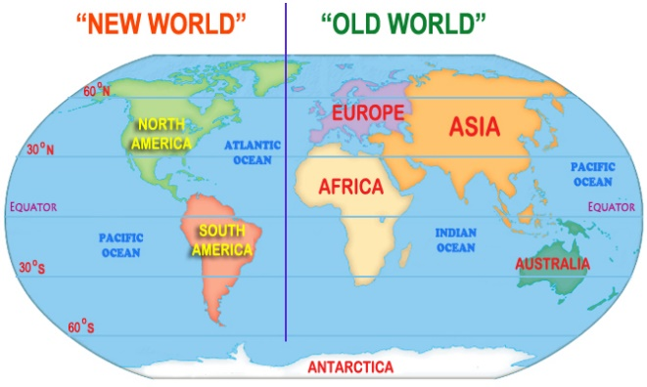 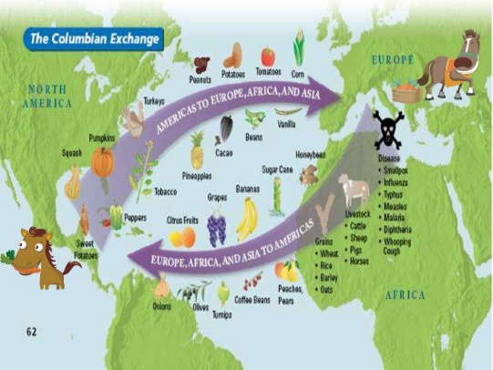
Find 10 things around your house that can be identified as coming from the Old
World or New World. Make a list, and indicate OW or NW.
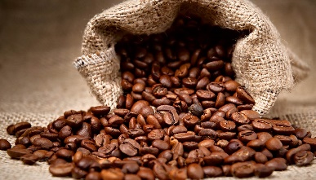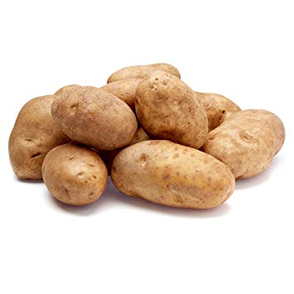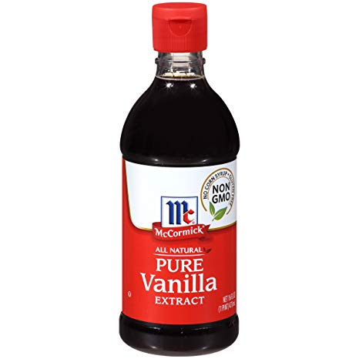

- _____________________________________________________
- ______________________________________________________
- _____________________________________________________
- ______________________________________________________
- _____________________________________________________
- ______________________________________________________
- _____________________________________________________
- ______________________________________________________
- _______________________________________________________
- _______________________________________________________
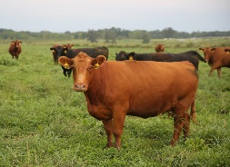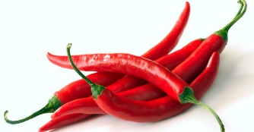
Chiles’ Global Warming
http://archive.aramcoworld.com/issue/201402/chiles.global.warming.htm

