Water Cycle Quiz

What percent of the water on Earth is fresh? _____ Salt water? _____
Why is water important to us, and to animals and plants?
______________________________________________________________________________________________________________________________________________________________________________
Tucson doesn’t have a river or lake nearby for water. Where does our water come from?
______________________________________________________________________________________________________________________________________________________________________________
What makes water evaporate into the air?
________________________________________________________________________________________________________________________
How does water move from plants into the air?
_____________________________________________________________________________________________________________________________________________________________________________
The way that water moves in a cycle is a circulation pattern. What bad things would happen if water suddenly stopped moving in a cycle?
____________________________________________________________________________________________________________________________________________________________________________________
In general, what is a cycle? _________________________________________
________________________________________________________________________________________________________________________
Who will you explain the water cycle to? _________________________________
Vocabulary

On your own paper, define these vocabulary words.

- Evaporation
- Water vapor
- Condensation
- Precipitation
- Runoff
- Percolation/Infiltration
- Aquifer
- Transpiration
- Fresh water
- Groundwater
- Saltwater

Label the actions in this diagram.
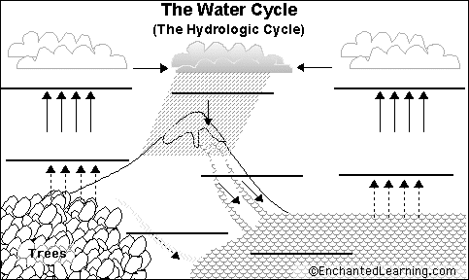

Very little rain or snow falls in the desert. Where does Tucson get its water from? Read this blog and write a brief summary.
Where does Tucson get its water? | Bryan Moravec's Blog (wordpress.com)

Water Cycle Answer Key

Evaporation: The process in which liquid water turns into water vapor in the air
Water vapor: Water that is a gas in the air
Condensation: Water vapor gets cold and turns back into droplets in clouds
Precipitation: When water falls out of the air as rain or snow
Runoff: Rainfall or melting snow that flows into a river or lake
Percolation/Infiltration: How water sinks down into soil
Aquifer: An underground layer that stores water
Transpiration: The way water moves out of a plant (like when you breathe on a mirror)
Fresh water: Non-salty water, the kind animals and plants need
Groundwater: Water stored in an aquifer. It can be pulled up from a well.
Saltwater: most water is in the oceans, which is salty and not drinkable

What percent of the water on Earth is fresh? __2.5%___ Salt water? _97.5%____
Why is water important to us, and to animals and plants?
Our bodies are more than 70% water, and we need to constantly take in fresh water and get rid or our body waste in urine. We need water every day, so it’s important to have a supply of clean water to drink. In nature, all plants and animals on earth need water to stay alive.
Tucson doesn’t have a river or lake nearby for water. Where does our water come from?
We used to have wells, but we pulled too much water out and the water level sank too low to reach. We now use CAP (Central Arizona Project) water from Lake Mead.
What makes water evaporate into the air?
Heat energy from the sun is absorbed by water, and the energy makes the water molecules rise into the air to become water vapor, a gas.
How does water move from plants into the air?
Plants breathe out water just like we do, as part of the natural cycle of growth.
The way that water moves in a cycle is a circulation pattern. What would happen if water suddenly stopped moving?
Almost everything would be affected. Without circulation, lakes would get full of algae and slime. We wouldn’t have rain or snow, and there would be no rivers or fresh water. Water would not evaporate from the ocean or lakes. It would be a disaster!
How is a cycle different from a one-way process?
Nothing is wasted or lost; the substance moves in a circular pattern through various states or conditions; if something stops the cycle, everything is affected and life can be endangered.

